Historical Association Ealing Branch programme Spring 2013
All talks are in the Parlour of Ealing Green Church, except 12 February (see below). Lectures start at 7.30pm, and refreshments are available from 7.00pm
Tuesday 8 January Susan Ronald on “Heretic Queen: Elizabeth and the wars of religion”.
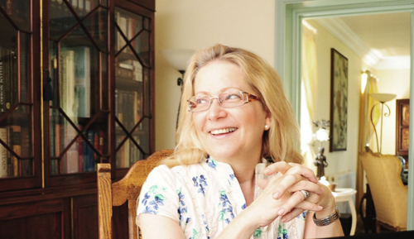
Susan Ronald’s book of the same title was published in 2012. She is an American who has lived in England for more than 25 years. With her husband she owns a film production company, and she is a screen writer and producer. She has a particular interest in Elizabeth I and has previously written about other aspects of the reign in The Pirate Queen in 2008.
Tuesday 12 February George Chamier on “Clement Attlee”
George Chamier was formerly Head of History at Bradfield College, and now works as a tutor, editor, examiner and author. He has published a book on The Greatest British Prime Ministers in which he reassesses the contributions of Gladstone, Lloyd George, Margaret Thatcher, and of course Clement Attlee.
This is our sixth form lecture and will take place in the Ealing Campus of Ealing, Hammersmith & West London College, The Green, Ealing, London W5 5EW, which is opposite Ealing Green Church.
Tuesday 12 March Dr Tony Constable on “Talma – my Revolutionary Ancestor”
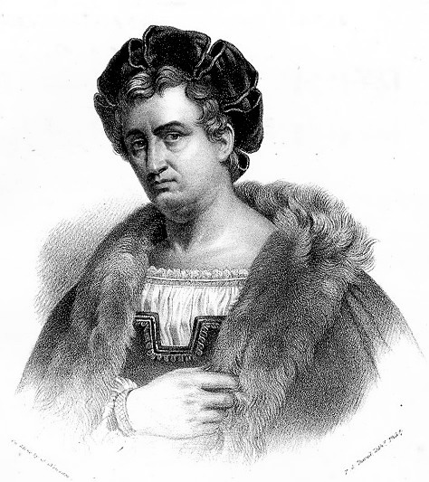
2013 is the 250th anniversary of the birth of François Joseph Talma. He became a celebrated actor in Paris during the Revolution and Empire periods and knew many of the great figures of the period, including Napoleon Bonaparte.
Tony Constable is a descendant of Talma

Tuesday 9 April Dr Sam Willis on “The Royal Navy at War in the Age of Nelson”
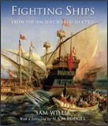
Dr Sam Willis is a maritime historian and archaeologist. His writing is infused with his own experience and knowledge of seafaring. Before becoming a full time author he spent eighteen months at sea on square-rigged sailing ships which included work on the Hornblower TV series and on Channel 4’s award winning film Shackleton. He has lectured and written widely on naval history particularly on warfare in the eighteenth and early nineteenth century. His latest book In the Hour of Victory is published in 2013.

Tuesday 14 May Lucy Hughes Hallett on “Gabriele d’Annunzio”
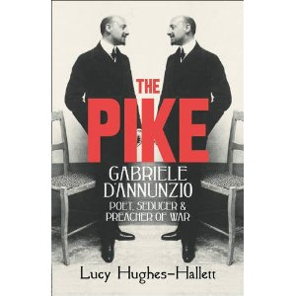
Lucy Hughes Hallett has visited the Ealing Branch before when she spoke about Garibaldi as one of the first celebrities and his reception in England. In her recently published book she looks at another famous Italian, born 150 years ago this year. This controversial character was a poet, a daredevil and an early Fascist. 