Newsletter of the Ealing Branch: issue 40 January 2014

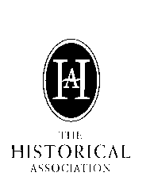
Branch programme Spring 2014

All talks are in the Parlour of Ealing Green Church,W5 5QT, except 11 February (see below). Lectures start at 7.30pm, and refreshments are available from 7.00pm. For further details see our branch website www.ealinghistory.org.uk

Tuesday 14 Jan 2014. - Dr John Maddicott - Simon de Montfort - Idealist or Adventurer?
Dr Maddicott was a Fellow and Tutor in Medieval History at Exeter College, Oxford, from until 2006. He has published works on the political, economic and social history of England in the 13th and 14th centuries. His book on The Origins of the English Parliament, 924-1327 (OUP, 2012) has been described as ‘one of the masterpieces of historical writing of our time’.

Tuesday 11 Feb. - Richard Ryan - ‘The Spanish Civil War’ . [N.B. This meeting will be held at Ealing, Hammersmith & West London College, Ealing Green, W5 5EW]
Richard Ryan is completing a PhD at Royal Holloway, University of London, on the impact of the Spanish Civil War on Liverpool's Catholic Community.

Tuesday 11 March - Professor Anita Prazmowska ‘Polish Migration to Britain During and After the Second World War’
Professor Prazmowska is Professor of International History at the London School of Economics, London University. Her most recent publication is Poland. A Modern History (I.B. Tauris, 2010)
Tuesday 8 April - Michael Gandy – ‘The story of the Huguenots’
Michael Gandy is former research officer of The Huguenot Society. Huguenots were French Protestants and an estimated 60,000 came to England in the late 1680s with a smaller number going to Ireland a bit later. This talk will cover their history, and the history of some other groups who are often mixed up with them, and give a simple guide to the records we have for tracing individual families.
Tuesday 13 May – Professor Justin Champion – ‘The Public History of Magna Carta’
Professor Champion is a strong proponent of public history and is a member of the Historical Association’s Committee of Public History. He has also been elected as the new President of the Historical Association. During his time as the head of the history department at Royal Holloway, the college began offering an MA programme in Public History in partnership with external heritage and media institutions. He has presented or appeared in several TV and radio shows about British history, particularly in the early modern period.
Tuesday 10 June 2014 – Dr John Ashdown-Hill ‘The Search for Richard III’
Dr Ashdown-Hill is a medieval historian and much published author. The Richard III archaeological project in Leicester was partly inspired by original research relating to King Richard III's burial published in his book The Last Days of Richard III, and also by his remarkable discovery of King Richard's mtDNA sequence.
This talk traces his discovery of the key strands of evidence behind this exploration: Richard III’s DNA sequence, and the truth about the history of his death and burial.
oooooooooooooOOOOOOOOOOOOOOOOOOOOOooooooooooooooooo

Report on Annual General Meeting 10 December 2013

The Annual General Meeting (2012-13) and Social was held on the 10th December 2013.

Eighteen members signed the attendance register.

1. The Treasurer reported that the Association currently has reserves of some £2,300. There had been some discussion by the committee as to the use to which it might be put. Some form of initiative with local schools had been considered. However a questionnaire circulated to all secondary schools in Ealing during the summer had brought only one reply (Twyford School) so the sentiment was that the funds should be spent on the Association’s own activities, such as paying for speakers from farther afield, and possibly subsidising some outings. It was suggested that we could liaise further with Twyford School which had also sent pupils to our meetings.

2. As Secretary, I reported on the speakers who had visited us over the previous year and the two outings to the Bank of England and Marble Hill House. I then issued my regular appeal for inspiration in subjects for speakers and outings. During the year I had done some research into the A level history curricula in local high schools and was struck by the relative modernity of the history modules now being taught - one even up to 2007. This raises interesting issues as to when one person’s experience became another’s history, and the extent to which this should be reflected in our programme, so all ideas welcome.

3. As to outings, there was some interest in whole-day outings with particular historical themes which would not overlap with those of other organisations, and will look into this further.

4. The current officers and committee members were re-elected unopposed:

Chairman Dr Peter Hounsell
Secretary Pierre Thomas
Treasurer Peter Crane
Newsletter/Publicity Officer Philip Woods
Refreshments: Richard Morse (pro tem- offers for this post are welcomed)
Additional members: Colin Emmins; Harry Chambers, Elizabeth Sunley, Liz Wood, Harriet Turner

5. After finishing the AGM by agreeing not to change the subscription, and some refreshment, our Chair Peter Hounsell celebrated the 150th anniversary of the London Borough of Ealing in the form of a ten-question quiz about its origins. The correct answers showed that it all began with a local board of health whose main concern was to improve public health following cholera epidemics, its first activity was to build sewers, its responsibilities only expanding towards the end of the century to become the Ealing Urban District Council. I regret that I only got four questions right and forgot to note all the correct answers, or the identity of the winner, but congratulations to her, and to Peter for presenting such learned research in such an entertaining manner.

Pierre Thomas – Secretary.

Treasurer's Report for the Year
Ending 30 June 2013

The accounts for the year were presented to headquarters shortly after the date required but I have heard nothing to suggest any problems and to the contrary we have received the quota from headquarters of £210. For some reason which is not clear that is £2 less than last year.
The opening balance brought forward from the year commencing 1 July 2012 was £1776.61 which was £60 more than the previous year. For the period from 1 July 2012 until the end of the financial year in June 2013 the income received was as follows: --
- payments for members over the year (32) £354
- quota from headquarters £212
- books £134.20
- refreshments £32.10
- monthly meetings £99.00
- excursions £18.00
Total £849.30

This is substantially lower than last year as we did not have the additional £400 resulting from the trip to Lille. There was also a lower amount recovered from the sale of books as the trip to York in particular and other many meetings resulted in increased expenses for the branch.
The expenses for the period were as follows: --
- administration (printing stationery postage and expenses) £464.60
- rent £315.00
- lecturers expenses £13.80
- publicity £63.00
- website (one off) £14.86
Total £871.26

I ascertained from the bank towards the end of November that we had in current-account the sum of £2365.48. There may be something to be added to that figure as we had a stall at the church's Christmas fete and we received about £60 which was to be shared with the church. The committee will have to decide which meetings it is financially worthwhile attending in the future.
If the meeting had any ideas as to how some of this money can be spent the committee would be interested in hearing from you.

Peter Crane, Hon. Treasurer

oooooooooooooOOOOOOOOOOOOOOOOOOOOOooooooooooooooooo

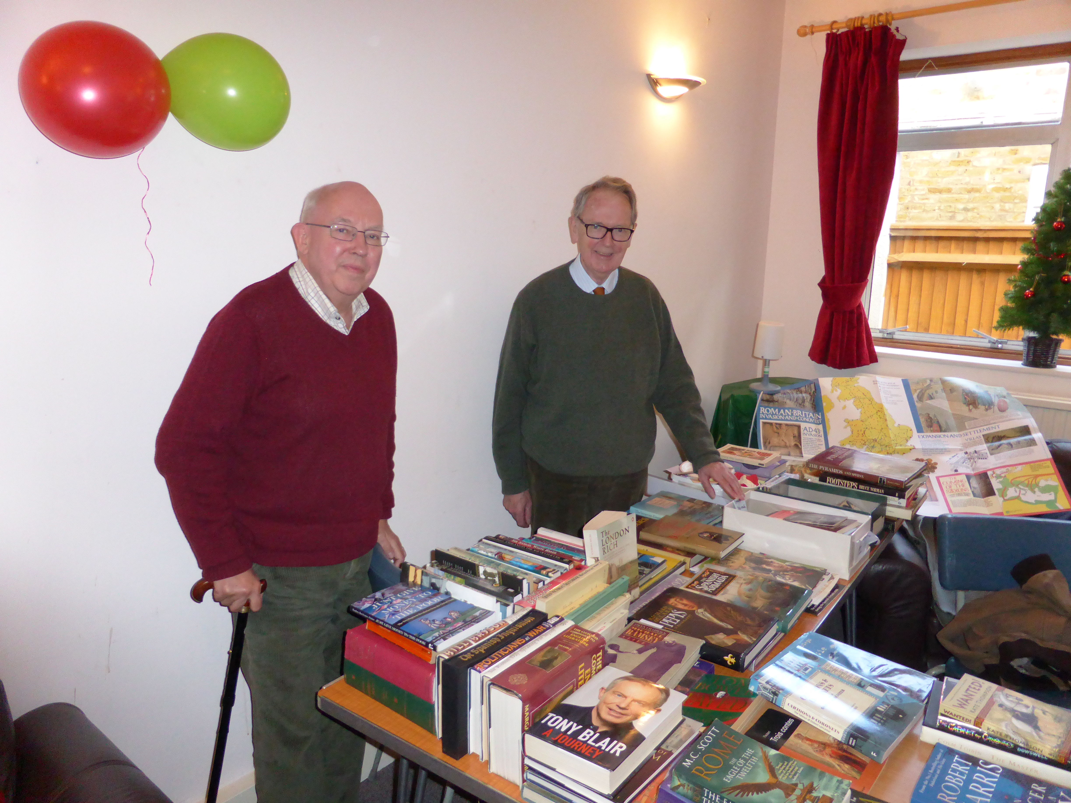
The Branch continues to benefit both financially and in terms of its public profile from the sterling work our ex-Chairman, Colin Emmins, in running book sales at local fairs and at the annual Historical Association Conference. Selected books are made available at our monthly lectures and are also listed on our website. Many thanks also to those who help move the books and look after the stalls. This picture shows our Treasurer, Peter Crane , with Colin, at a new venture, a Christmas Craft Fair at Ealing Green Church.

HAPPY NEW YEAR!

Philip Woods Newsletter Editor, 6 Elm Crescent, W5 3JW. philip.woods@tiscali.co.uk

